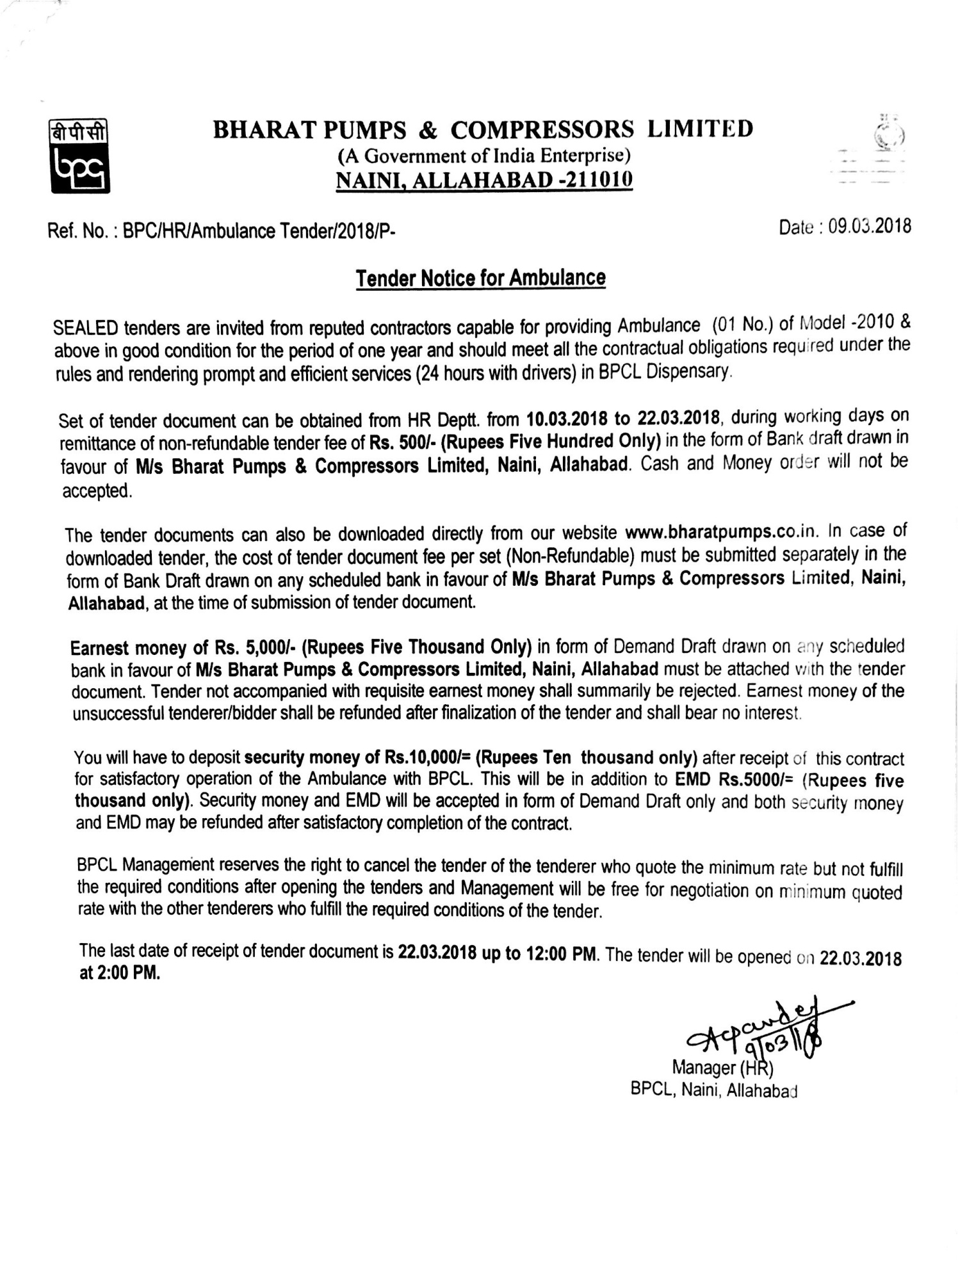

BHARAT PUMPS & COMPRESSORS LIMITED
(A Govt. of India Enterprises)
Naini, Allahabad-211010

Ref. No. BPC/PR/Ambulance-Tender/2018/P- Date :
SEALED OFFER FOR NEW AMBULANCE
Type of Vehicle : ……………………………………………………………………………
- Model : …………………………………………………………………………….
- Registration No. : ……………………………………………………………………………
- Name of Owner & Address : ……………………………………………………………………………
- Photocopies of documents
- Registration Book : ……………………………………………………………………………
- Tax paid upto : ……………………………………………………………………………
- Insurance upto : ……………………………………………………………………………
- Pollution certificate etc. : ……………………………………………………………………………

- Rate offered for 1000 Kms per month : ……………………………………………………………………………
- Rate offered extra kms : ……………………………………………………………………………
Running @ Rs……….. per kms.
beyond 1000 kms.

- (a) Demand Draft No. or Receipt No. ……………………………….. Date ……………………………………………
Amount Rs. ……………………………. On Bank ………………………………………………………………………….

(b) BPCL Cash deposit receipt No. ……………. Dated …………………. Amount Rs. ………………………….

Signature of Tenderer ………………………………………………….
Name ……………………………………………………………………………..
Address ………………………………………………………………………….
……………………………………………………………………………………..
Tel No. …………………………………………………………………………..

CHECK – LIST
In case of the parties not meeting any of the following criteria indicated in the following check list or not submitting the required proof, their tender will not be accepted.
- EMD as per tender document to be accompanied with tender document.

- Commercial registration paper of ambulance with tender document.

- Insurance paper of vehicle with tender document.

- Pollution Certificate with Tender document.

- Copy of Driving License of the Driver to be deposited with tender document.

- Security deposit as per tender document to be deposited after LOI date but
before putting vehicle in operation.
√
- Photocopy of PAN CARD of tenderer to be submitted, with tender document.

- Undertaking in writing for complying with PF/ESI norms as per concerned Acts
to be submitted with tender document.

- In case of new vehicle of Model – 2010 the time limit for fulfilling the conditions
of tender to be submitted within one month of getting LOI. After the expiry of this
time limit their contract will be terminated automatically.

NOTE :
√
To indicate in each box above with a tick mark. (I) if YES
(II) if NO
X

(Signature of the Vehicle Owner)
Name :
Address :
Date :

GENERAL TERMS & CONDITIONS
- In normal circumstances minimum run of vehicle in a calendar month would be up to 1000 Kms. for which Rs. ……………… shall be paid.

- For extra run over and above 1000 Kms. in a Calendar month, payment will be made at the rate of Rs. ……….. per Km.

- The contractor will operate the Ambulance round the clock at BPC works Naini, Allahabad including Holidays / Weekly off days for company’s duties. However, the Ambulance can be released once in a month on weekly off day on prior intimation for maintenance / servicing etc. after providing substitute arrangement.

- The contractor will have to submit the documents of Registration, Insurance etc. of the vehicle before providing the vehicle in the Company. In absence of these documents, the vehicle will not be allowed to run in the Company & entire EMD and security deposit money of the contractor will be forfeited.

- In case above Ambulance goes out of order, alternate /substitute Ambulance, after due approval from HD Department will have to be provided to BPC by the contractor.

- In case for any reasons what so ever, contractor fall to provide the above Ambulance and / or unable to transport our Employees / Patients on any day as the case may be, in addition to proportionate recovery for hiring charges the contractor shall have to pay us by way of liquidated damages a sum equal to double of the hire charges for that day.

- BPCL shall not liable for wear, tear, maintenance or loss or damage to Ambulance while in use or while garaged or parked in BPCL Naini, Allahabad.

- The contractor should have comprehensive Insurance Policy to cover the passengers traveling in the subject vehicle and vehicle to cover the risk of accident, death and payment of compensation as per rules /law in force for the time being.

- The contractor shall obtain the Registration from RTO, for running of the Ambulance and BPCL shall no way be responsible for patterning such certificates etc. Payments pertaining to Road Tax, Surcharge, Insurance charges etc & all other local taxes to the concerned authorities will be contractor’s liability and BPCL will no way be responsible to pay such taxes etc. Contractor will have to produce the documents of Ambulance as and when required by the authorities / authorized officer of BPCL.

- The tenderers will have to deposit the Earnest Money of Rs. 5000/- (Rupees Five Thousand Only) in Finance Department of BPCL & submit the receipt with the tender form or attach the Demand Draft of such money in favour of Bharat Pumps & Compressors Ltd. with the tender form otherwise the tender form will not be accepted. EMD will be refunded to those tenderers who will fail to get award of the tender.

- The contractor will have to deposit the Earnest Money of Rs. 10000/- (Rupees Ten Thousand Only) after receipt of this contract for satisfactory operation of the Ambulance with BPCL. This will be in addition to EMD Rs. 5000/- (Rupees Five Thousand Only) security money and EMD will be accepted in form of Demand Draft or cash deposit in Finance Department of BPCL and both security money and EMD may be refunded after satisfactory completion of the contract.

Contd…2/

-2-
- The responsibility or keeping the Ambulance in good running condition and also to bear the cost of duel etc including salary and wages of the Driver employed by contractor for running the Ambulance, would exclusively be of contractor and BPCL will no way be responsible to pay any such expenditure.

- The contractor will have to run the Ambulance with punctually so that the duties entrusted shall not be delayed or disrupted.

- The contractor will keep and send the Driver in proper Uniform (white Shirt & white Paint) with Driving License always with him.

- In case of any breach of terms & conditions of this contract by the Contractor, BPCL shall be entitled to forfeit the security money deposited against the Ambulance without prejudice to the right of BPCL and to take legal re-course for the said breach of contract as per law.

- In the event of any question or dispute arising under these terms & conditions in connection with operation of Ambulance, the same shall be decided by the officers of BPCL and his decision shall be final and binding on both parties.

- In case of any rise in the rates of fuel, by Government notification request for any increase / decrease in case the contractor fails to provide the contracted Ambulance or provide proper timely service, as required, BPC will have the right to terminate the contract without any notice.

- The contractor’s contract can be terminated by giving one month notice, in writing to this effect. However, in case the contractor fails to provide the contracted Ambulance or provide proper timely service, as required, BPC will have the right to terminate the contract without any notice.

- Ambulance owner will not be entitled to claim any damages or compensation from BPC in any condition.

- The vehicle offered should not be earlier than 2010 Model. The offer for other earlier Models will not be considered and there will be no weight age for the Model higher than 2010.

- The Management reserves the right to accept or reject any tender document of any tenderer without assigning any reason whatsoever.

- The payment to contractor will be made through RTGS (to their Bank Account) on production of monthly bills.

- In case the vehicle meets accident due to negligence of Driver, contract of vehicles may be cancelled.

- Contractor shall make payment of minimum wages to the Driver of the vehicle and also have to provide PF/ESI code to deposit their PF/ESI deduction as per statutory requirement. In this regard an undertaking in writing has to be submitted with offer by Tenderer with the tender document with in one month failing which their contract will be deemed to be terminated.

(Signature of the Vehicle Owner)
Name :
Address :
Date :

